Topic- college management system

Main page-

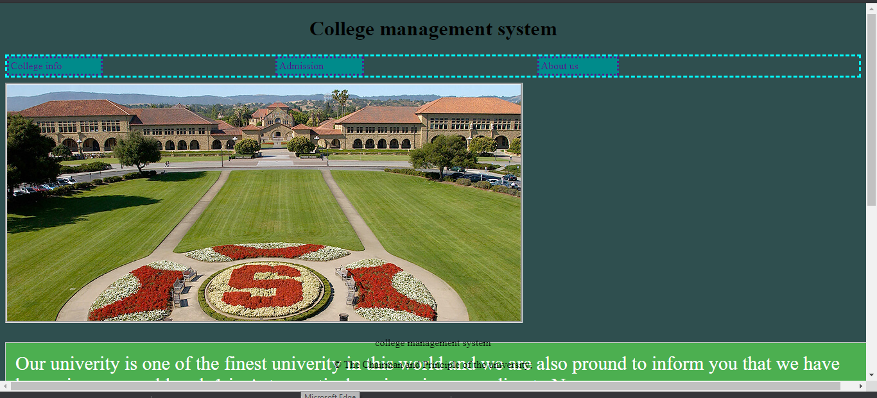

This is the main page 1 using which we can go to other pages such as college info ,admission and about us page which is in navigation bar .

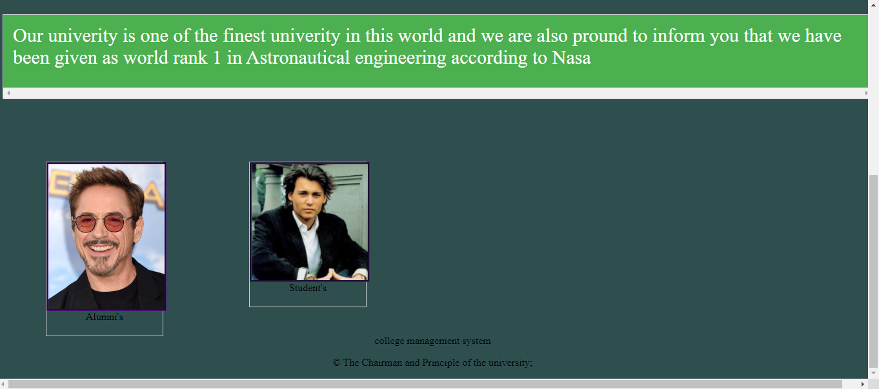

The main page continuous as we scroll down which contains small note about the university and the link to alumni and student as we click on them respectedly, in footer we have the project name followed by copyright.

College info page-

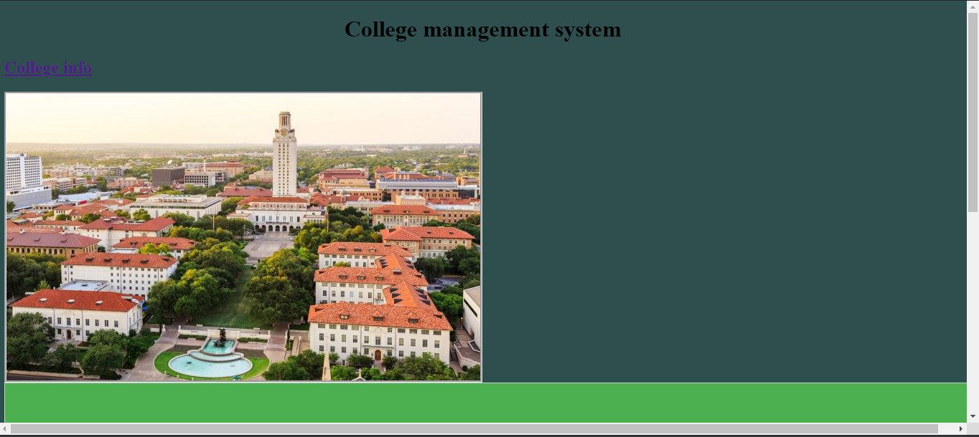image 1

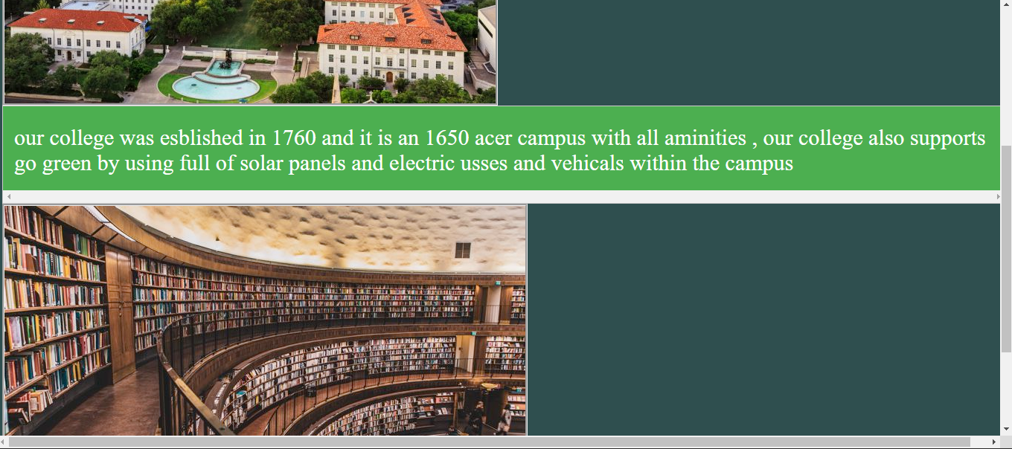IMAGE 2

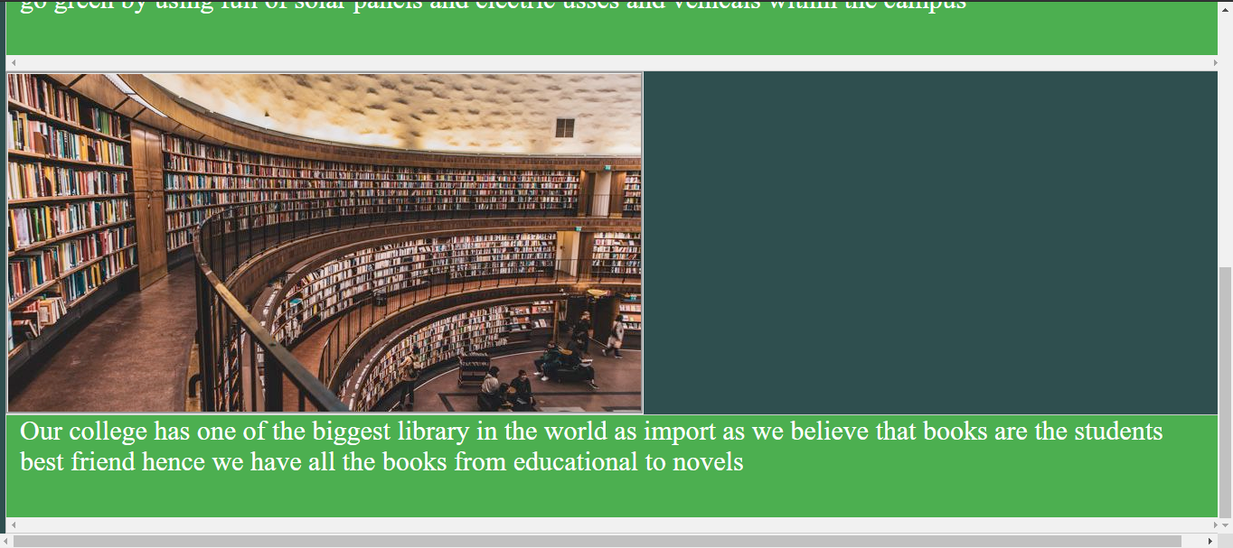

Image 3

ADDMISSION PAGE-

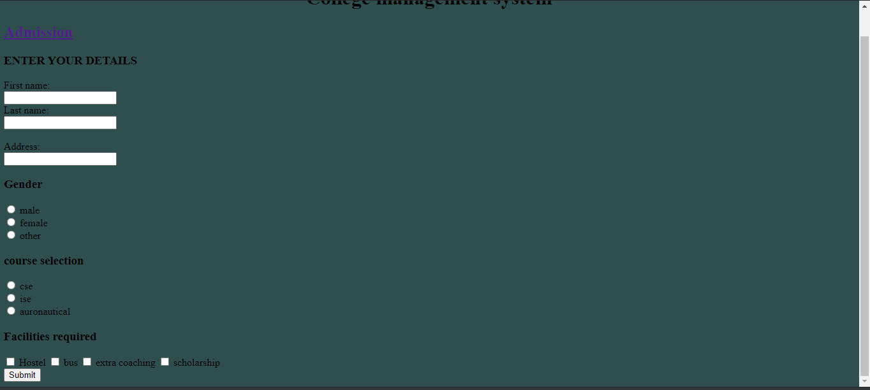

This is the admission page

About us page-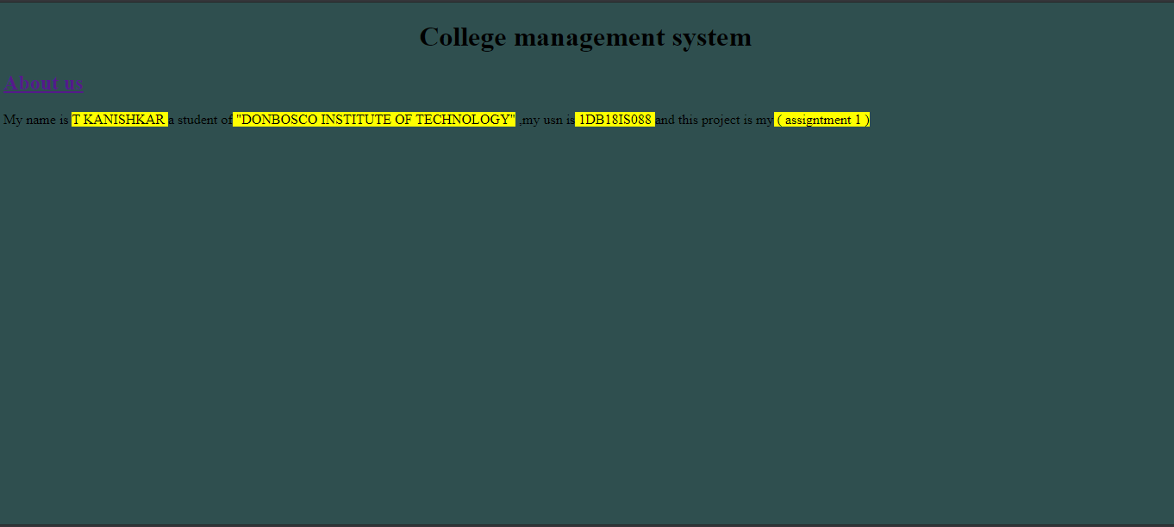

This is the about us page

Alumni page-

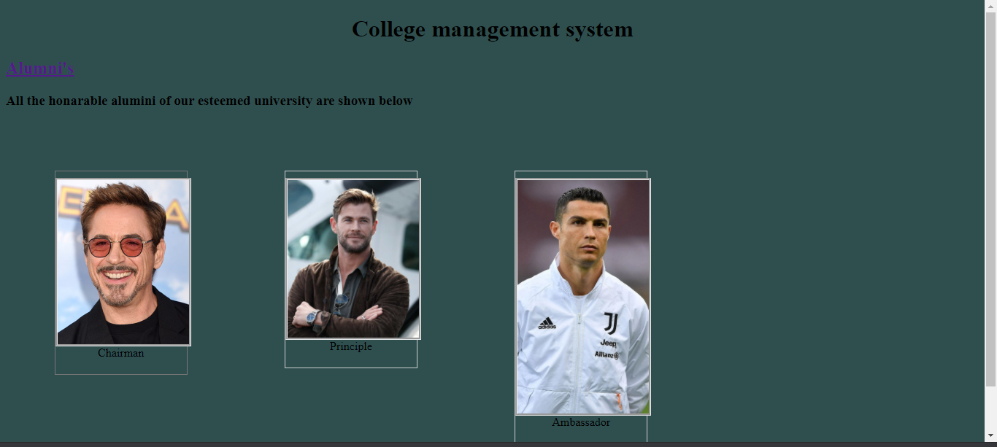

This is the alumni’s page

Student page-

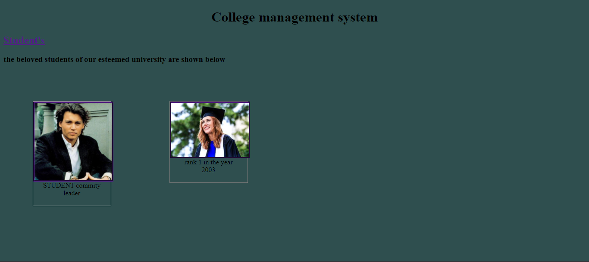

This is the student page